

Vietnamese tax implications on flash-title- transfer transactions inside bonded warehouse

Client VN is contemplating to participate in a toll manufacturing model with Client TW (Parent of Client VN) whereby the transaction flow is as follows:
- The materials will be imported and stored at the Vietnamese bonded- warehouse by the overseas supplier of ABC Singapore (“ABC SG”);
- Whenever Client TW places an order of materials to ABC SG, the title of the materials will be transferred from ABC SG to Client TW in the Vietnamese bonded-warehouse. At that time there will be two flash-title- transfer transactions occurred:
  - ABC SG’s supplier will transfer the title of goods to ABC SG;

  - ABC SG will transfer immediately the title of goods to Client TW.
- Client TW, as the owner of the goods, will consign the materials to Client VN for toll manufacturing.
The transactions are illustrated as below:
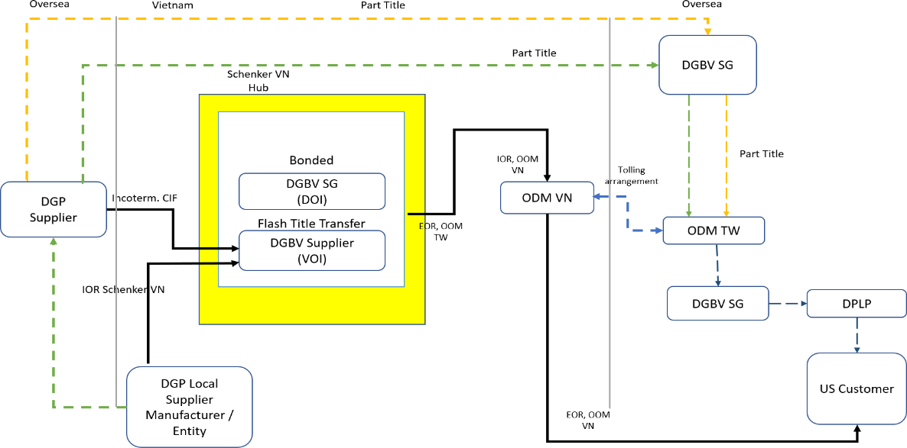

KPMG provided high level comments on the income tax implications for Client VN/Client TW of the flash-title-transfer transactions in the Vietnamese bonded-warehouse.
Our comments here below were provided from local tax perspectives only without considering legal aspects of the transaction.

Tax implications on the flash-title-transfer transactions
- Under the Law on Corporate Income Tax (“CIT”), the foreign companies carrying out business and generating income in Vietnam shall be subject to CIT in Vietnam, specifically:
  - Foreign companies having Permanent Establishments (“PE”) in Vietnam shall pay tax on taxable incomes arising in Vietnam that are not related to the PE's operations; and
  - Foreign companies not having PE in Vietnam shall pay tax on taxable incomes generated in Vietnam.1
- Given this, the flash-title-transfer transactions in Client VN’s case will be considered trading activities of foreign companies (i.e. ABC SG and ABC SG’s supplier) to generate income in Vietnam and hence, will be subject to income tax in Vietnam.
There has been a number of official letters (“OL”) of Ministry of Finance and Department of Taxation confirming such tax treatment for similar cases (i.e. OL

1 Article 2, Law on Corporate Income Tax No. 14/2008/QH12 on tax payer

No. 2389/TCT-CS for Canon Singapore’s case, OL No. 3997/TCT-CS for Sagawa’s case and OL No. 1474/TCT-DNL for Sabic’s case);
The risk of exposing to income tax of this flash-title-transfer transaction, therefore, is considered high.
- There is no clear mechanism on how to declare and pay taxes on this type of transactions under the current tax regulations. However, the taxing mechanism was guided/mentioned under the above OLs;
- In practice, the policy makers are becoming well aware of this kind of business model and may insist to tax by carrying out tax audits at the bonded warehouse management or the logistics companies, on the basis that the bonded warehouse managers are required to notify the Customs Office regarding the transfer of ownership of goods stored at the bonded warehouse for management and supervision under the Customs regulations.2
- The “substance over form principle” was enacted under the Law on Tax Administration 2019 which is effective from 01 July 2020, being the principle applied in tax administration to analyze transactions and business activities of taxpayers to determine the corresponding tax obligations.3
- Given the above, the absence of taxing mechanism would not reduce the level of tax risk since (i) the transaction is taxable in principle and (ii) a number of OLs have confirmed taxing mechanism in practice. Since the responsibilities to withhold, declare and pay taxes rests with income payment organization (i.e.
Client TW) in practice, it is recommended that a private ruling should be obtained from the local tax authorities to confirm the tax position of the transaction and the mechanism to declare and pay taxes in Vietnam.

2 Clause 9, Article 91, Circular No 38/2015/TT-BTC dated 25 March 2015, amend by Clause 59, Article 1, Circular No 39/2018/TT-BTC dated 20 April 2018 on Customs procedures
3 Point 25, Article 3, Law on Tax Administration No 38/2019/QH14

